Synopsis

Sentiment Analysis of Product Reviews using Machine Learning

Problem Id: 16
Section-L

Student names :- University Roll no. :-
Devansh Panwar (Leader) 2028702
Rishabh Budakoti 2028820
Tushar 2028886

- Problem Description:
In today’s digital world, a large number of product reviews are generated on e-commerce platforms. Analyzing these reviews manually is time-consuming and inefficient. This project focuses on designing an end-to-end machine learning system that automatically classifies product reviews into positive, negative, or neutral sentiments.
Therefore, this project aims to design and develop an end-to-end machine learning pipeline that processes raw product review data and classifies it into three sentiment categories: Positive, Negative, and Neutral, enabling efficient and scalable analysis of customer feedback.

Problem/Review | Sentiment
Reviews | Positive/ Negative/Nuetral
The system uses Natural Language Processing (NLP) techniques to preprocess raw text data by removing noise such as punctuation, HTML tags, and stopwords. The cleaned text is converted into numerical features using TF-IDF vectorization. Multiple machine learning models including Logistic Regression, K-Nearest Neighbors (KNN), and Support Vector Machine (SVM) are trained to classify sentiments.
The performance of models is evaluated using accuracy, precision, recall, F1-score, confusion matrix, and ROC curve. This system helps businesses understand customer opinions, improve products, and make data-driven decisions efficiently.

- Steps of Implementation:
1. Data Collection:
The first step in our project is collecting a suitable dataset.
We collected a dataset of product reviews from Kaggle, which is a popular platform for datasets and ML projects.
Kaggle- https://www.kaggle.com/
On Kaggle, we searched for keywords like:“sentiment dataset”,“product review sentiment”
We selected a dataset that contains:Text column → user reviews,Sentiment column → labels (Positive, Negative, Neutral)
Why this dataset?-It already contains labeled data → supervised learning(makes the model practical)
2. Data Preprocessing:
Raw text data is unstructured and noisy, so it cannot be directly used by machine learning models. Therefore, we perform data processing to clean and standardize the text.
There are 9 columns in the dataset . There are 3535 rows in the dataset . The coloumns we used for the Data Preprocessing are text, sentiment .
~Removed noise (punctuation, URLs, symbols)- These do not contribute to sentiment,⁠They confuse the model
- text = re.sub(r'http\S+','',text) # remove links
-text = re.sub(r'[^a-zA-Z ]','',text) # remove symbols & numbers
~Converted text to lowercase- Avoid duplication of words
-text = text.lower()
~Tokenization- Breaking a sentence into individual words (tokens). Since ⁠Machine learning works on words, not sentences
- text="This product is good"
→ ["this", "product", "is", "good"]
~Stopword removal- Common words that appear frequently but do not carry important meaning.
-Examples:⁠ is, the, and ,was, are, etc.
- text="this product is very good"
→ ["product", "good"]
~ Lemmatization- Converting words to their base/root form.
- Example: text= running → run, better → good, cars → car
~ Removing Empty Data-Sometimes after cleaning, text becomes empty.
- data = data.dropna()
Cleaned data - https://github.com/DevanshTECHAI/Sentiment_Project/blob/main/Sentiment_Project/sentimentdataset.csv

3. Feature Extraction:
After preprocessing, we still have text data, but machine learning models cannot understand text directly.
Models like Logistic Regression, KNN, and SVM work only with numbers.
text "good product" → [0.3, 0.7, 0, 0, ...] ⁠- This is called feature extraction
TF-IDF stands for:TF = Term Frequency IDF = Inverse Document Frequency
Term Frequency -Counts how often a word appears in a sentence.
Inverse Document Frequency- Measures how important a word is across all documents.
Logic:⁠Common words → low importance, ⁠Rare words → high importance
Final TF-IDF Value - TF-IDF = (TF × IDF)
vectorizer = TfidfVectorizer(max_features=5000)
X = vectorizer.fit_transform(data['Cleaned'])
⁠Converts text → numerical vectors , ⁠Keeps top 5000 important words,⁠Reduces complexity
4. Data Splitting:
Split dataset into training (80%) and testing (20%)
X_train -⁠ Features for training
⁠ X_test ⁠ - Features for testing
⁠ y_train ⁠ - Labels for training
⁠ y_test ⁠ - Labels for testing
X_train, X_test, y_train, y_test = train_test_split(X, y,test_size=0.2, random_state=42)
5. Model Training:
After splitting the data, we train machine learning models so they can learn patterns between text and sentiment.
We used 3 models: Logistic Regression, KNN (K-Nearest Neighbors), SVM (Support Vector Machine)
~Logistic Regression- A classification algorithm used to predict categories.
-Assigns weights to words, Calculates probability of each class
Example:
⁠text good → +2.5
bad → -3.0
⁠- If total score is positive → Positive sentiment
Code:
lr = LogisticRegression(max_iter=1000)
lr.fit(X_train, y_train) ⁠
~ K-Nearest Neighbors (KNN)- ⁠Stores all training data,⁠ ⁠Finds K closest reviews, ⁠Predicts based on majority
Code:
knn = KNeighborsClassifier(n_neighbors=5)
knn.fit(X_train, y_train)
~Support Vector Machine (SVM)- A powerful classification algorithm.
-Creates a boundary between classes •⁠ ⁠Separates positive, negative, neutral data
Code:
⁠svm = SVC(probability=True)
svm.fit(X_train, y_train)
6. Model Evaluation: After training the models, we evaluate their performance using different metrics to understand how well they are predicting sentiment.
Accuracy- measures how many predictions made by the model are correct overall.
Accuracy= TP+TN /(TP+TN+FP+FN)
Where:
TP = True Positive. , TN = True Negative
FP = False Positive. , FN = False Negative
~Precision- tells how many of the predicted positive values are actually correct.
Precision=TP/(TP+FPP)
~ Recall- Recall measures how many actual positive cases the model correctly identified.
Recall=TP(TP+FN)
~F1-score- F1-score is the harmonic mean of Precision and Recall.
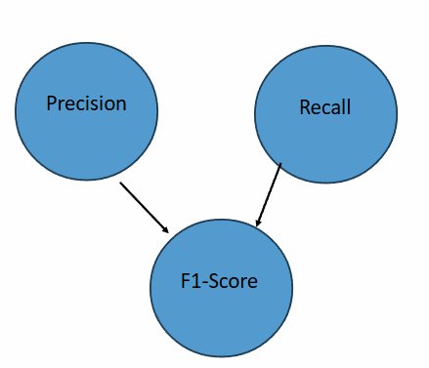
~Confusion Matrix- A Confusion Matrix is a table used to evaluate the performance of a classification model by comparing actual vs predicted values.
Predicted Positive Predicted Negative
Actual Positive TP (True Positive) FN (False Negative)
Actual Negative FP (False Positive) TN (True Negative)
~ ROC Curve- ROC Curve is a graph that shows the performance of a classification model at different thresholds.
X-axis: False Positive Rate (FPR). , Y-axis: True Positive Rate (TPR / Recall)
TPR= TP /(TP+FN) , FPR=FP(FP+TN)

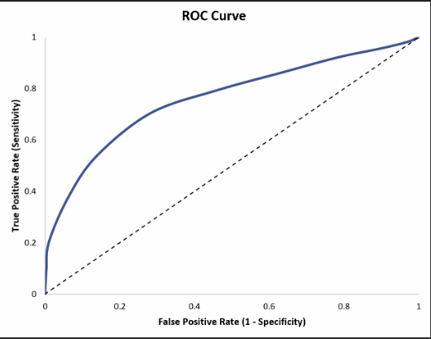
7. Prediction System:
User inputs review → system predicts sentiment
- Expected Modules/ Libraries to be used :
1. Pandas: A library used for data handling and manipulation.
To load dataset
To work with rows and columns
To clean and filter data
~ How we use it:
import pandas as pd
data = pd.read_csv("sentimentdataset.csv")
2. NumPy: A library for numerical operations and arrays.
Helps in handling numerical data
Works behind the scenes in ML models
~ How we use it:
import numpy as np
Supports TF-IDF and model calculations
3. NLTK: A library for Natural Language Processing (NLP).
Text preprocessing
Stopword removal
Lemmatization
~ How we use it:
from nltk.corpus import stopwords
from nltk.stem import WordNetLemmatizer
4. Scikit-learn:A powerful library for machine learning.
Model training
Feature extraction
Evaluation
(A) Train-Test Split
from sklearn.model_selection import train_test_split
- Splits data into training & testing
(B) TF-IDF Vectorizer
from sklearn.feature_extraction.text import TfidfVectorizer
-Converts text → numerical features
(C) Machine Learning Models
from sklearn.linear_model import LogisticRegression
from sklearn.neighbors import KNeighborsClassifier
from sklearn.svm import SVC
- Used for sentiment classification
(D) Evaluation Metrics
from sklearn.metrics import confusion_matrix
from sklearn.metrics import classification_report
from sklearn.metrics import roc_curve, auc
5. Matplotlib:A library for data visualization.
To plot graphs
To compare models
To show ROC curve
~ How we use it:
import matplotlib.pyplot as plt
~ Accuracy graph:
plt.bar(models, accuracies)
~ ROC curve:
plt.plot(fpr, tpr)
6. Re (Regular Expressions): Used for text pattern matching and cleaning.
Remove unwanted patterns like:
URLs
Special characters
Numbers
~How we use it:
import re
text = re.sub(r'http\S+','',text)
text = re.sub(r'[^a-zA-Z ]','',text)

- Expected Evaluation metrics and Plots to be used:
1. Accuracy: - measures how many predictions made by the model are correct overall.
Accuracy= TP+TN /(TP+TN+FP+FN)
Where:
TP = True Positive
TN = True Negative
FP = False Positive
FN = False Negative
2. Precision: tells how many of the predicted positive values are actually correct.
Precision=TP/(TP+FPP)
3. Recall:Recall measures how many actual positive cases the model correctly identified.
Recall=TP(TP+FN)
4. F1-score:
F1-score is the harmonic mean of Precision and Recall.


5. Confusion Matrix:A Confusion Matrix is a table used to evaluate the performance of a classification model by comparing actual vs predicted values.
Predicted Positive Predicted Negative
Actual Positive TP (True Positive) FN (False Negative)
Actual Negative FP (False Positive) TN (True Negative)

6. ROC Curve:ROC Curve is a graph that shows the performance of a classification model at different thresholds.
X-axis: False Positive Rate (FPR)
Y-axis: True Positive Rate (TPR / Recall)
TPR= TP /(TP+FN)
FPR=FP(FP+TN)
7. Accuracy Graph:
Compares performance of Logistic Regression, KNN, and SVM models.

~Required topics from the subject:
1. Machine Learning Fundamentals
Supervised Learning
Classification problems
Sentiment analysis is a classification task
Input → Review text
Output → Positive / Negative / Neutral
2. Natural Language Processing (NLP)
Text preprocessing
Language understanding
Cleaning text data
Processing human language into machine-readable form
3. Text Preprocessing Techniques (Converts raw text into clean and usable format)
Lowercasing
Tokenization
Stopword removal
Lemmatization
Noise removal
4. Feature Extraction (TF-IDF) (Based on Term Frequency–Inverse Document Frequency)
Converts text → numerical vectors
Helps model understand importance of words
5. Classification Algorithms (Used for training sentiment prediction models
Compared performance of different algorithms)
Logistic Regression
K-Nearest Neighbors
Support Vector Machine
6. Model Training and Testing (Data split into training and testing sets
Ensures model works on unseen data)
Train-test split
Generalization
7. Model Evaluation Metrics (Used to evaluate model performance
Helps select best model)
Accuracy
Precision
Recall
F1-score
Confusion Matrix
ROC Curve
8. Data Visualization (Accuracy comparison graph
ROC curve visualization)
Graph plotting
Performance comparison
9. End-to-End Machine Learning Pipeline
Data collection
Preprocessing
Feature extraction
Model training
Evaluation
Prediction
~Visual studio
- Books and Link Sources:
1. https://www.kaggle.com (Dataset source)
2. https://scikit-learn.org (Machine Learning documentation)
3. https://www.nltk.org (NLP library documentation)
4. Hands-On Machine Learning with Scikit-Learn (Book)
5. https://www.geeksforgeeks.org (Concept reference)

